**A**

**Project Report On**

**“Global Stock Market Prediction Based on Stock**

**Chart Images Using Deep Q-Network”**

# Submitted By

Student Name PRN No. Mr. Aniruddha Kasar 72151669G Mr. Shreyas Borkar 72151629H

Mr. Aniket Surve 72151721J

### Under the Guidance of

### Prof Prinkya kumbhar

***In partial fulfillment of***

**Savitribai Phule Pune University**

**Department of Information Technology**

at



PARVATIBAI GENBA MOZE COLLEGE OF ENGINEERING, WAGHOLI, PUNE-412207

2023-2024

Parvatibai Genba Moze College

## Department of Information Technology

Wagholi-412207



***CERTIFICATE***

This is to certify that the project entitled **Global Stock Market Prediction Based on Stock Chart Images Using Deep Q-Network** submitted by **Aniruddha Kasar , Shreyas Borkar , Aniket Surve** is a record of bonafide work carried out by him/her, in the partial fulfillment of the requirement for the award of Engineering in Information Technology at Parvatibai Genba Moze College, Wagholi under The Savitribai Phule Pune University. This work is done during the year 2023-2024, under our guidance.

### --------------------------

**Internal Project Guide**

### ------------------------- HOD

[Prof.Priyanka Kumbhar] [Prof. Abidali Shaikh]

### Examiner

**Principle**

**[**External] [P.G.Moze COE]

Date :

Place : Wagholi

# Acknowledgement

We express our sincere thanks to all those who have provided us the valuable guidance towards the successful completion of this system as a part of syllabus for the bachelor‘s course. We express our sincere gratitude towards our co-operative department for providing us with altheas valuable assistance and equipment for the system development. We hereby take this opportunity to sincerely thank **Prof.Priyanka Kumbhar** for his valuable guidance, inspiration, whole hearted involvement during every stage of this project and his experience, perception through professional knowledge which made it possible for us in successfully realizing the concept.

We are also thankful to **Prof. Abidali Shaikh** - Head of Department – Information Technology for his constant enlightenment, support and motivation which has been highly instrumental in successful completion of our project phase 1.

We are extremely thankful to **Dr. Navnath Narawade** Principal - PGMCOE, Wagholi for his encouragement and providing us the opportunity and facilities to carry out this work.

Finally, we like to express our deep sense of gratitude towards our parents, friendsand well- wishers who were always there for suggestions and help.

# Abstract

In this study, we present a novel approach to global stock market prediction using a Deep Q-Network (DQN) with a Convolutional Neural Network (CNN) function approximator. Our model is designed to analyze stock chart images as input to make predictions on the future movements of stock prices. Remarkably, our model not only demonstrates profitability when applied to the US stock market, where it was trained, but also consistently yields positive returns in 31 different countries over a span of 12 years. We exclusively trained our model on historical data from the US stock market and then evaluated its performance on diverse international stock markets. Our findings reveal that the portfolios constructed based on our model's predictions typically generate returns ranging from 0.1% to 1.0% per transaction, prior to considering transaction costs, across the 31 countries tested. These results suggest the presence of patterns in stock chart images that exhibit consistent correlations with stock price movements on a global scale. Moreover, our study demonstrates the remarkable transferability of our model's predictive capabilities. Even when trained and tested on data from different countries with varying market characteristics, our model consistently demonstrates the ability to forecast future stock prices effectively. This suggests that artificial intelligence-based stock price forecasting models can be employed in relatively small and emerging markets, even in cases where limited historical data is available for training. In summary, our research underscores the potential of combining deep reinforcement learning techniques with CNNs for stock market prediction. Our model not only exhibits profitability in multiple global markets but also highlights the existence of universal patterns in stock chart images that transcend geographical boundaries. This research opens up exciting possibilities for the application of AI-based forecasting models in diverse and data-constrained financial markets, ultimately enhancing investment decision-making processes.

**Keywords:** Entrepreneur‘s, Platform, Startup culture, Economic growth, Entrepreneurship, Investment, Professionals.

# LIST OF CONTENTS

1. Title Pages -
2. Acknowledgment i
3. Abstract ii
4. Index iii
5. List of figures v
6. List of Tables vi

**INDEX**

**Sr. No Chapter Name Page No**

1. **Introduction…………………………………………………………. 01-01**

1.1 System Introduction………………………………………………………….01

* 1. Motivation……………………………………………………………………01

1.3 Objective…………………………………………………………………………...01

**2 Literature Survey……………………………………………….……02-03**

**3. Problem Statement……………………………………………..…….04**

* 1. Problem Definition…………………………………………………………….04
  2. Scope………………………………………………………………………………….04

**4. Software Requirement Specification.................................................05-07**

* 1. Functional Requirement… ........................................................................……05
  2. Non-Functional Requirement… ........................................................................05
  3. Software Requirement… ..........................................................................…….06
  4. Hardware Requirement….........................................................................……..07

**5. Project Requirement Specification………………………………....08-09**

* 1. Purpose…………………………………………………………………….…...08
  2. Overall Description…………………………………………….………………08
  3. External Interface Requirement………………………………………………...08
  4. System Features………………………………………………………………...08
  5. Other Nonfunctional Requirement…..……………………………............….....09
  6. Amazon Web Server(AWS)……………………………………………………..
  7. Docker………………………………..…………………………………………………
     + 1. **Proposed System Architecture............................................................10-10**
       2. **High Level Design of Project.....................................................……..11-17**

7.1 Data Flow Diagram………………………….…………………………………..11

* + 1. DFD Level 0……………………...…….…………………………...…….11
    2. DFD Level 1…………………………………………………...……….....11
  1. E-R Diagram…………………………………………………...…………………..12
  2. UML Diagram…………………………………………...…………………………13

7.3.1 Use Case Diagram………………………...…….……………………………13

* + 1. Class Diagram……………………...………………..……………………….14
    2. Activity Diagram……………....……………………….…………………….15
    3. Sequence Diagram…………………………………………….……………...12

**8. Test Cases**………………...…………………………………………………………………..**18-22**

8.1 Introduction……………………………………………………………………………18

8.2 Testing Scope…………………………………………………………...…………….18

8.3 Basic of Software Testing………………………………………...…………..............18

1. White-Box Testing……………………………………..…………….…………….18

2. Black-Box Testing………………………………..………………….……………..19

3. Unit Testing……………………………….………………………….………….…19

4. Integration Testing…………………………………………………..….…………..20

5. Validation Testing………………………………………………...………………...20

6. System Testing……………………………………………..……………………….20

8.4 Test Strategy……………………………………………….…………………...............20

1. Testing Process…………………………………...…………………………………21

2.Functionality testing & non-functionality testing……………………………………21

8.5 Test Case………………………………………………………………...……………...22

**9. Working Module**…………………………………………………........................................**23-32**

9.1 Module.............................................................................................................................23

9.2 Code................................................................................................................................23

9.3 Snapshots........................................................................................................................32

**10. Project Plan**……………………………………………………….........................................**33-33**

**11. Conclusion………………………………………………………………….34-34**

Bibliography…………………………………………………………………………………35-35

APPENDIX………………………………………………………………………………….36-41

APPENDIX A…………………………………………

**LIST OF FIGURES**

|  |  |  |
| --- | --- | --- |
| Figure No | Figure Name | Page No. |
| 7.1.1 | DFD Level 0 | 16 |
| 7.1.2 | DFD Level 1 | 16 |
| 7.1.3 | DFD Level 2 | 17 |
| 7.2 | ER Diagram | 18 |
| 7.3.1 | Use Case Diagram | 19 |
| 7.3.2 | Class Diagram | 20 |
| 7.3.3 | Activity Diagram | 21 |
| 7.3.4 | Sequence Diagram | 22 |
| 7.3.5 | State Diagram | 23 |
| 10 | Project Plan | 31 |

**LIST OF TABLE**

Table No. Table Name Page No.

* 1. Software Requirement 09
  2. Hardware Requirement 09

8.2 Test Cases 25

# CHAPTER 1

**INTRODUCTION**

# System Introduction:

Stock price prediction is a difficult task. It is because there is no certain variable that can precisely predict the stock price every day. Based on Efficient Market Hypothesis (EMH), new information is a significant factor that effects changes of stock price [1]. This information, such as news about company can influence people decision whether they will buy the company's stock. More people buy the company's stock, the price is getting higher. People tend to buy a company with good reputation. One way to know company's reputation is by seeing relationship between the company and customer [2]. The explosion of social media usage forces many companies to create their official account in social media in order to keep in touch with their customer. This make customer can express their opinion about products easily. One of the social media that commonly used by company is Twitter.

There are several researches about how the information from social media can affects the stock price. Based on research conducted by Johan Bollen. et.al [3]. it concluded that certain mood states of Twitter data can predict the Dow Jones Industrial Average (DJIA) value with 87.6% accuracy. Another research conducted by Anshul Mittal and Arpit Goel [4], shows that with the DJIA value, calmness and happiness mood states of twitter data on previous days can predict the DJIA value on the current day with 75.56% accuracy. This shows that information from Twitter can really be used to predict stock data.

The contribution of this research lies in the use of existing classification and prediction algorithm to the dataset. The dataset consists of twitter dataset and stock price dataset. Twitter dataset used was in Bahasa and stock price dataset retrieved from several companies in Indonesia.

# Motivation:

The motivation behind the project, "Global Stock Market Prediction Based on Stock Chart Images Using Deep Q-Network," can be encapsulated in a single driving force: the pursuit of more accurate and insightful stock market predictions in an increasingly data-driven and interconnected financial world. As financial markets continue to evolve, they generate an overwhelming volume of data, making it imperative to explore innovative approaches to harness this information effectively. The core motivation stems from recognizing the untapped potential of visual data contained within stock chart images, which, when coupled with the power of deep learning through Deep Q-Networks, can provide a unique vantage point for predicting stock price movements.

# Objectives:

The Goals and Objectives of the given system are as follows:

* + - Establish a Unified Platform for Diverse Startups.
    - Provide Comprehensive Investment Information.
    - Simplify Investment for Investors.
    - Strengthen the Startup Ecosystem.
    - Enhance Investor Confidence.
    - Ensure Accessibility and Conveniene.

# CHAPTER 2

**LITERATURE SURVEY**

The literature survey provides valuable insights into the Indian startup ecosystem and its impact on the economy. Several academic studies and research papers have contributed to understanding the trends, investment patterns, and government initiatives related to startups in India.

1. **isec.ac.in - Indian Startup Ecosystem: Analysing Investment Trends**

This study delves into investment trends and the performance of government programs related to Indian startups. It contributes to the limited academic literature available on this topic, shedding light on the dynamics of the Indian startup ecosystem.

1. **mckinsey.com - Online and upcoming:**

The Internet's impact on India This research explores how the internet impacts India's economy both currently and in the future. It provides insights into the influence of the internet on various sectors and its potential to drive economic growth.

1. **srcc.edu - Startups Restoring The Indian Economy?**

This paper discusses the current innovative startup environment in India and highlights its role in restoring the Indian economy. It presents essential details about the startup ecosystem within the Indian context.

1. **mdpi.com - The Impact of Fintech and Digital Financial Services on**

While primarily focusing on fintech, this study investigates the impact of behavioral intention, trust in fintech services, usability, and social influence on user engagement. It offers insights into the evolving landscape of financial services in India.

1. **adb.org - Experiences from the Startup Action Plan in India**

This source provides insights into the Startup Action Plan (SAP) of 2016 in India. It addresses key areas for empowering startups, including funding and simplification, offering an understanding of the initiatives aimed at supporting the startup ecosystem.

1. **orfonline.org - The Indian startup ecosystem: Drivers, challenges and**

This paper analyzes the Indian startup ecosystem's current state and explores growth drivers, challenges, and support pillars. It provides an in-depth understanding of the factors shaping the Indian startup landscape.

# CHAPTER 3 PROBLEM STATEMENT

* 1. **Problem Definition:**

• To develop a machine learning based application to accurately predict the predicting stock prices using financial news article.

The purpose of this work is to find correlation between some features we can measure about the company and the stock price. An intelligent investor might have observed, however, that the stock price is not exactly related to business performance. Instead, it can be influenced by numerous factors such as large and small economic events, public perception, expectation of change, new trends in products, new trends in consumer behavior and many others.

# Scope:

The scope of the project, "Global Stock Market Prediction Based on Stock Chart Images Using Deep Q-Network," is designed to revolutionize the field of stock market prediction by harnessing the potential of deep learning and visual data analysis on a global scale. This ambitious project aims to break the geographical boundaries of stock market forecasting, allowing investors and traders worldwide to benefit from its advanced capabilities.

At its core, the project employs state-of-the-art Deep Q-Network (DQN) technology to decode the intricate patterns hidden within stock chart images. While it was initially trained on US stock market data, its scope extends far beyond national borders. The platform's primary objective is to provide accurate stock price predictions that transcend geographic limitations, enabling users to make informed investment decisions in markets across the globe.

* **Prediction Target:** The project's primary objective is to predict stock price movements. It does not cover other financial aspects such as portfolio optimization or trading strategies.
* **Training and Testing:** The model is trained on historical data from the US stock market. It will be tested on stock market data from 31 different countries spanning 12 years, with a focus on assessing its ability to provide profitable predictions.
* **Market Type:** The project's focus is on both well-established and emerging markets. It aims to demonstrate the model's adaptability to markets with varying degrees of data availability and liquidity.
* **Technology Stack:** The project utilizes technologies such as Deep Q-Network, Convolutional Neural Networks, and various software tools like Flutter, Angular, ChartJS, SpringBoot, AWS, Docker, and CSS for developing a platform to visualize and evaluate stock market predictions.
* **Legal and Ethical Considerations:** The project acknowledges the need to comply with legal and ethical regulations governing stock market prediction and trading activities in various countries.
* **Scalability:** While the project aims to be applicable to different markets, it may require adjustments and fine-tuning to suit the specific characteristics of each market.
* **Profitability:** The project aims to demonstrate the model's ability to yield a profit, but it does not eliminate the risk associated with stock market investments. Users should be aware of potential financial risks.
* **Documentation:** The project may require comprehensive documentation to support users in understanding and using the platform effectively.

# CHAPTER 4

**SOFTWARE REQUIREMENT SPECIFICATION**

# Functional Requirement:

The functional requirements for the project, "Global Stock Market Prediction Based on Stock Chart Images Using Deep Q-Network," encompass a range of essential functionalities that ensure the platform's effectiveness and utility. These functional requirements include:

**Data Collection and Integration:**The platform must collect and integrate stock chart images and related data from various global stock markets.It should support real-time data updates to provide users with the latest market information.

**Deep Learning Model:**Implement the Deep Q-Network (DQN) for analyzing stock chart images and making predictions.Train and fine-tune the DQN using historical stock market data.

**User Authentication and Profiles:**Provide user registration and authentication features. Allow users to create and manage their profiles.Market Analysis and Prediction:Analyze stock chart images to identify patterns and trends.Generate stock price predictions and provide confidence levels for predictions.

**Visualization and Reporting**:Present stock market data and predictions in an intuitive and visually appealing manner.Offer customizable charts and reports for users to track their investments.

**User Alerts and Notifications:** Implement notification features to alert users of significant market events or changes in predictions. Allow users to set personalized alerts based on their preferences.

**Global Market Coverage:** Include support for multiple stock exchanges and markets worldwide.Ensure that users can access data and predictions for various countries and regions.

**User Interaction:**Develop user-friendly web and mobile interfaces for interacting with the platform.Enable users to input specific stock preferences and customize their experience.

**Performance Optimization:** Optimize the platform's performance to handle large volumes of data and user interactions. Ensure low latency for real-time data updates and predictions.

**Security Measures:** Implement robust security measures to protect user data and financial information. Encrypt sensitive data and ensure compliance with data protection regulations.

# Non Functional Requirement:-

* **Performance:**The platform should respond to user requests promptly, with low latency. It should handle a large volume of concurrent users and data without significant performance degradation.
* **Scalability:** The system must be scalable to accommodate future growth in data and user base.

It should handle an increasing number of stock markets and data sources.

* **Reliability:** The platform should be highly reliable, with minimal downtime or service disruptions.
* It should include redundancy and failover mechanisms to ensure uninterrupted service.
* **Security:** User data, including personal information and financial details, must be securely stored and transmitted.Implement strong authentication and authorization mechanisms to protect user accounts.
* **Usability:** The user interface should be intuitive and user-friendly, catering to both novice and experienced users.Accessibility features should be implemented to ensure inclusivity.
* **Availability:** The platform should be available 24/7, with minimal scheduled maintenance windows.
* **Interoperability:**Ensure compatibility with various web browsers and mobile devices.Support integration with third-party financial data providers and services.
* **Data Storage and Management:**Data should be stored efficiently, with mechanisms for data archiving and retrieval.Implement data retention policies to manage historical data.

# Software Requirement:

|  |  |
| --- | --- |
| **Language** | Python, HTML, CSS |
| **Database** | Mongo-DB |
| **Frameworks** | **Flask** |
| **Server** | Streamlite |
| **Deployment Tool** | Docker[20.10.21] |
| **IDEs** | Visual Studio[17.4],Pychamp, Jupyter Notebook |

# Hardware Requirement:

|  |  |
| --- | --- |
| **Name of Component** | **Specification** |
| Processor | Intel Core i3 |
| RAM | 4 GB |
| Hard disk | 1TB |

# CHAPTER 5

**PROJECT REQUIREMENT SPECIFICATION**

**5.1.1Purpose**

Stock price prediction is a difficult task, since it very depending on the demand of the stock, and there is no certain variable that can precisely predict the demand of one stock each day. However, Efficient Market Hypothesis (EMH) said that stock price also depends on new information significantly. So, the purpose of this work is to develop an application to accurately predict stock price.

**5.1.2 Document Conventions**

This is the Software Requirements Specification (SRS) for 'Stock price prediction by analyzing news sentiment'. The purpose of this document is to give information about the end user's requirements, both functional and non-functional to the reader.

**5.1.3 Intended Audience and Reading Suggestions**

Audience of this SRS are other project developer, users like students, viewers that will use system. This SRS contains detail description about the product, its functioning, different external interfaces required, system features, Non functional requirements and some additional requirements.

**5.1.4 Product Scope**

Our purpose on this research is to predict the Indonesian stock market using simple sentiment analysis. Naïve Bayes and Random Forest algorithm are used to classify tweet to calculate sentiment regarding a company. The results of sentiment analysis are used to predict the

company stock price. We use linear regression method to build the prediction model. Our experiment shows that prediction models using previous stock price and hybrid feature as predictor gives the best prediction with 0.9989 and 0.9983 coefficient of determination.

**5.2. Overall Description**

**5.2.1 Product Perspective**

An offline signature verification scheme basically uses some network or mechanism as a classifier and a database in which some specimen signatures are stored. Features are extracted for each stored signature and when a new signature is employed it is matched using the classifier it as which Classify genuine or forgery.

**5.2.2 Product Functions**

* + Highly accurate.
  + Cloud based - scalable, anytime, and anywhere access.
  + Store data on Amazon AWS or Google Cloud.
  + Visualization in the form of chart, map graph for better understanding.

**5.2.3 User Classes and Characteristics**

In our system have mainly two, first is the who uses a system, second is the administrator.

* User: user who can use application to predict stock price.
* Admin: These users has an authority to update, schedule and Configure a system.

**5.2.4 Operating Environment**

Our project is based on cloud and user application runs on all platforms. So, we need

any device like mobile, tablet, desktop to run the application.

**5.2.5 Design and Implementation Constraints**

There are three major components for our system are client App, cloud, stock API.

**5.2.6 User Documentation**

User manual will be provided with this system.

**5.2.7 Assumptions and Dependencies**

Only assumptions in the system is that user has knowledge of smartphone and internet.

**5.3 External Interface Requirements**

**5.3.1 User Interfaces**

The user of the system must have a device with working internet connection to access

application.

**5.3.2 Hardware Interfaces**

No hardware interfaces needed except Device to use application.

**5.3.3 Software Interfaces**

Our project is based on image processing and machine learning so, required libraries must be installed like Pandas, TensorFlow, NumPy etc

**5.3.4 Communications Interfaces**

The system can be worked in both online and offline mode hence, communication interfaces are compulsory

**5.4 System Features**

**5.4.1 System Feature**

* 1. **Description and Priority**
     1. Predict stock price: Priority is high
  2. **Functional Requirements**
     1. Request data from stock and news API.

1. Train Model.
2. Predict stock price

**5.5 Other Nonfunctional Requirements**

**5.5.1 Performance Requirements**

The system should take immediate action and show result as fast as possible.

**5.5.2 Safety Requirements**

The system/application is currently in developing phase so, don't use for legal purpose.

**5.5.3 Security Requirements**

Here the system works in offline mode so, there is no need of security mechanism.

**5.5.4 Software Quality Attributes**

1. **Reliability**
   1. The reliability that user can easily use application to predict stock price without any overhead.
2. **Availability**
   1. System deployed on amazon AWS cloud so there is 99.9% availability.
3. **Maintainability**
   1. Our system usually not required maintenance until some modification to be done.
4. **Portability**
   1. The application is works on all platforms.

# 5.6 Amazon Web Service(AWS):

AWS represents Amazon Web Services it needs no proper presentation, given its massive fame. The main cloud supplier in the commercial center is Amazon Web services. It gives more than 170 AWS administrations to the designers so they can get to them from anyplace at the period of scarcity. AWS has clients in more than 190 nations around the world, including 5000 ed-tech foundations and 2000 government associations. Many organizations like ESPN, Adobe, Twitter, Netflix, Facebook, BBC, and so forth, use AWS administrations. For instance, Adobe makes and updates programming without relying on the IT groups. It involves its administrations by offering multi-terabyte working conditions for its clients. By conveying its administrations with Amazon administrations, Adobe coordinated and worked its product in a straightforward way.

AWS Meaning: The Amazon Web Services (AWS) stage gives in excess of 200 completely highlighted administrations from server farms found everywhere, and is the world's most thorough cloud stage. Amazon web administration is an internet based stage that gives versatile and financially savvy distributed computing arrangements. AWS is an extensively embraced cloud stage that offers a few on-request tasks like figure power, data set capacity, content conveyance, and so on, to help corporates scale and develop.

AWS typically works in a few unique designs relying upon the client's necessities. Be that as it may, the client should have the option to see the sort of arrangement utilized and the specific server map regarding the AWS Services.

# Docker:

Docker is an open stage for creating, delivery, and running applications. Docker empowers you to isolate your applications from your foundation so you can convey programming rapidly. With Docker, you can deal with your framework in the same ways you deal with your applications. By exploiting Docker's systems for transportation, testing, and conveying code rapidly, you can essentially diminish the deferral between composing code and running it underway.

Docker gives the capacity to bundle and run an application in an inexactly disconnected climate called a compartment. The confinement and security permits you to run numerous holders all the while on a given host. Compartments are lightweight and contain everything expected to run the application, so you don't have to depend on what is presently introduced on the host. You can undoubtedly share holders while you work, and be certain that everybody you share with gets the very compartment that works similarly.

Docker gives tooling and a stage to deal with the lifecycle of your holders:

* + 1. Foster your application and its supporting parts utilizing holders.
    2. The container becomes the unit for distributing and testing your application.
    3. At the point when you're prepared, convey your application into your creation climate, as a compartment or a coordinated help. This works a similar whether your creation climate is a nearby server farm, a cloud supplier, or a mixture of the two.

# CHAPTER 6

**PROPOSED SYSTEM ARCHITECTURE**

In this project we have two main modules first is user module and second is admin module. In user module user can able to use various services offer by platform like business, investor, professional‘s and entrepreneur‘s. If user wants to use platform first he needs to go through authentication process then he can explore various services offer by the platform. Admin module has controlling all the activity in the platform like user authentication and other services.

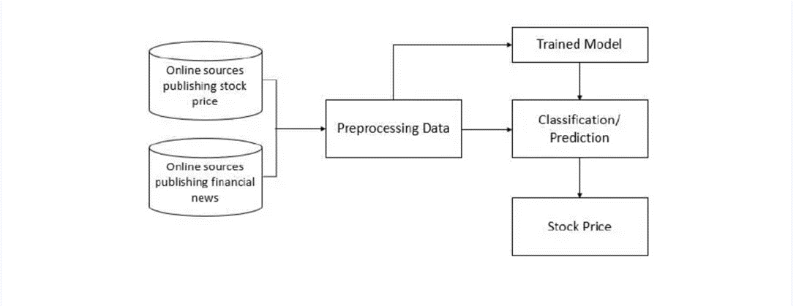

**Area Of Project**

1. Machine Learning
2. Deep Learning
3. Computer Version (opencv)
4. Cloud computing

**Algorithm Used**

1. Linear regression
2. CV2
3. Long-shot Term Memory (LSTM)

**Advantages**

* Overcome risk of false detection.
* Data will be accessible from anywhere and anytime.
* Eliminates Risk due to inaccurate prediction.

# CHAPTER 7

**HIGH LEVEL DESIGN OF THE PROJECT**

# Data Flow Diagram:

Data flow diagram is graphical representation of flow of data in an information system. It can depict incoming data flow, outgoing data flow and stored data. The DFD does not mention anything about how data flows through the system.

There is a prominent difference between DFD and Flowchart. The flowchart depicts flow of control in program modules. DFDS depict flow of data in the system at various levels. DFD does not contain any control or branch elements.

* + 1. **Data Flow Diagram Level 0:**

Level 0- Highest abstraction level DFD is known as Level 0 DFD, which depicts the entire flow of

Project.

* + 1. **Data Flow Diagram Level 1:**

The Level 0 DFD is broken down into more specific, Level 1 DFD. Level 1 DFD depicts basic modules in the system and flow of data among various modules. Level 1 DFD also mentions basic processes and sources of information

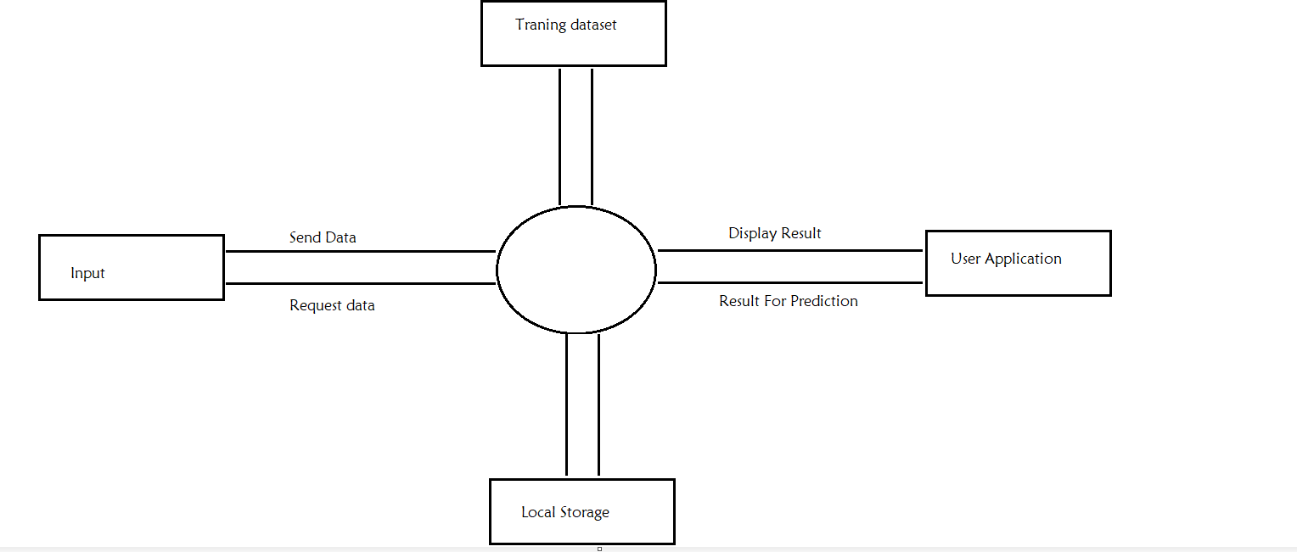

* + 1. **Data Flow Diagram Level 2:**

UML (Unified Modeling Language) is a standard language for specifying, visualizing, constructing, and documenting the artifacts of software systems. UML was created by the Object Management Group (OMG) and UML 1.0 specification draft was proposed to the OMG in January 1997. It was initially started to capture the behavior of complex software and non-software system and now it has become an OMG standard. This tutorial gives a complete understanding on UML.

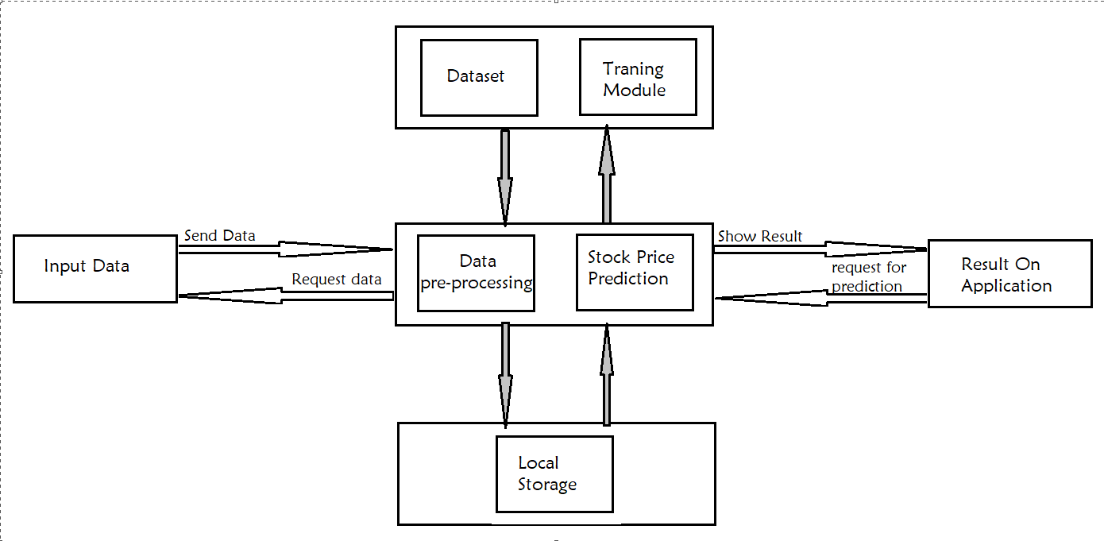

# Entity Relationship Diagram:

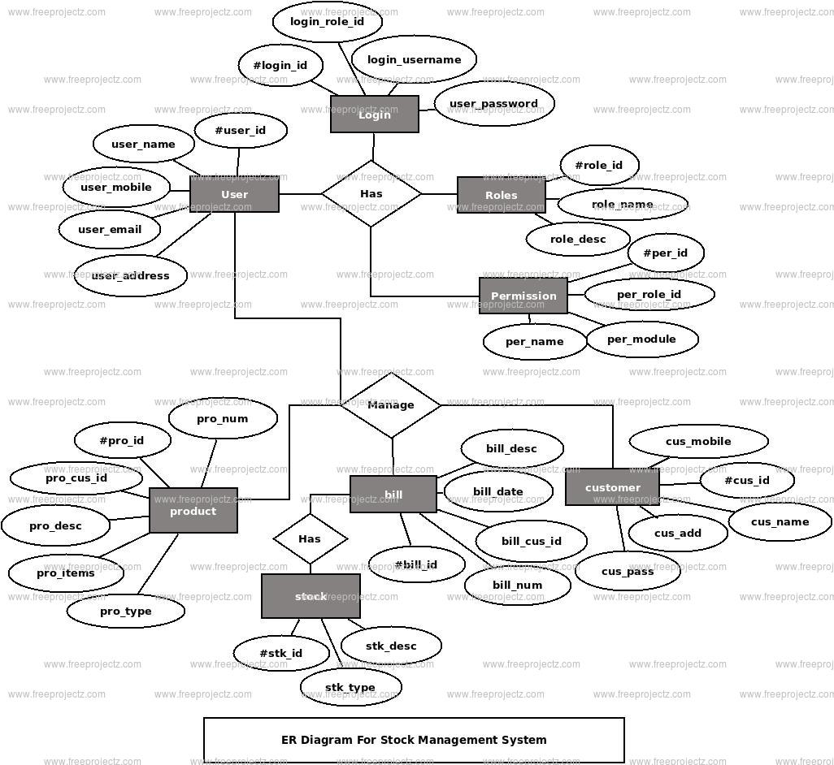

* 1. **UML:**

### Use Case Diagram:

The purpose of use case diagram is to capture the dynamic aspect of a system. However, this definition is too generic to describe the purpose, as other four diagrams (activity, sequence, collaboration, and State chart) also have the same purpose. We will investigate some specific purpose, which will distinguish it from other four diagrams

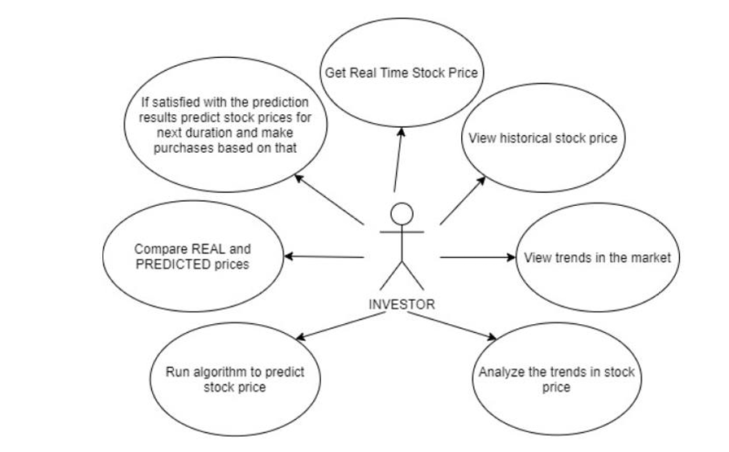

### Class Diagram:

Class diagram is a special kind of diagram in UML. The purpose is also different from all other diagrams discussed so far. It does not describe the functionality of the system, but it describes the components used to make those functionalities

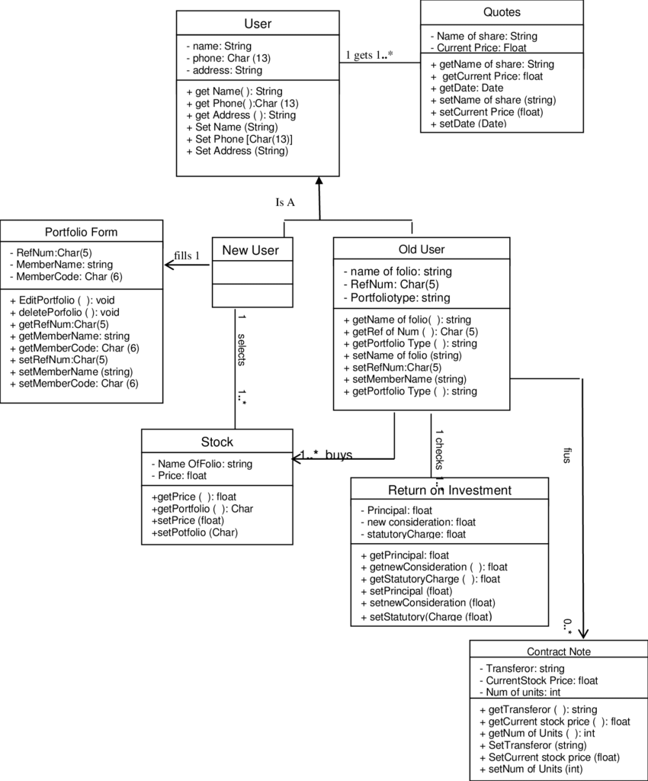

### Activity Diagram:

The basic purposes of activity diagram is similar to other four diagrams. It captures the dynamic behavior of the system. Other four diagrams are used to show the message flow from one object to another, but activity diagram is used to show message flow from one activity to another

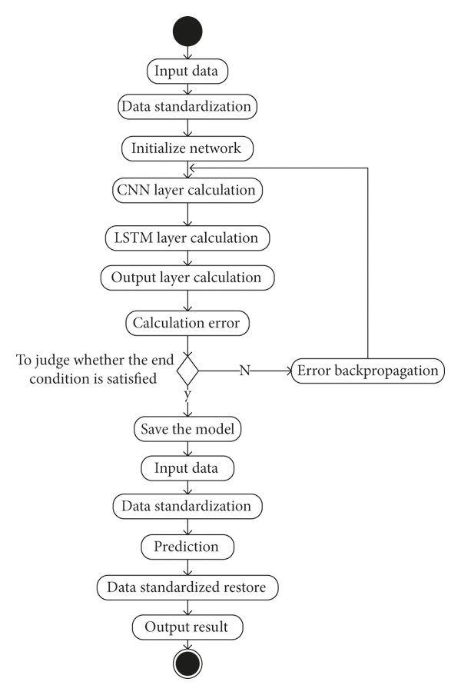

### Sequence Diagram:

The purpose of interaction diagrams is to visualize the interactive behavior of the system. Visualizing the interaction is a difficult task. Hence, the solution is to use different types of models to capture the different aspects of the interaction.

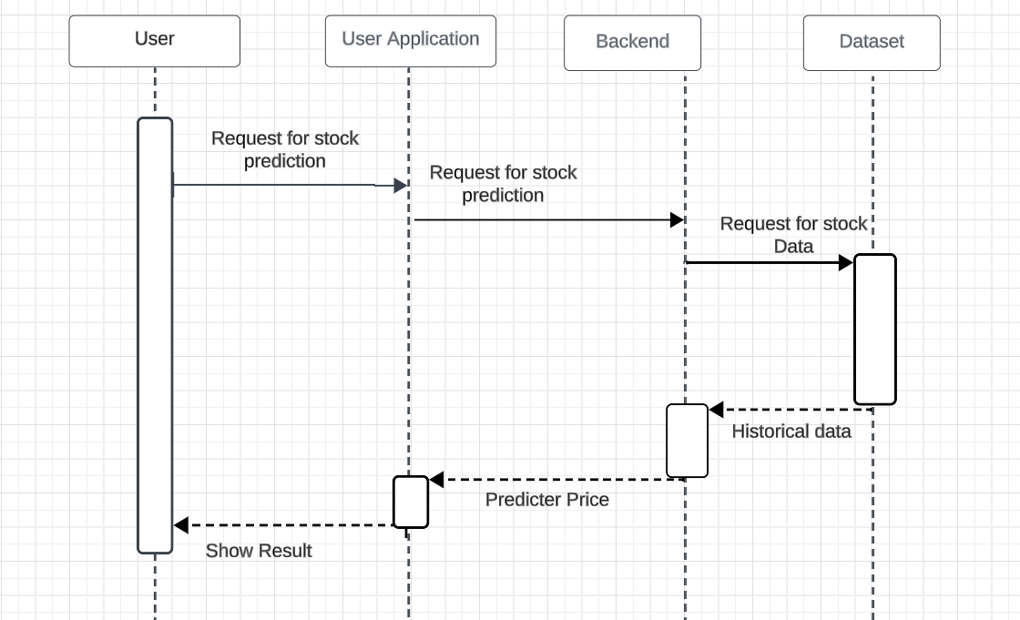

### State Diagram:

A state diagram describes the behavior of the system this behavior analyses and represented as a series of events the at can occur in one or more possible states. State diagram focuses on flow of control from one state to another state. It shows work flow of our model. In the following figure shows different states, transitions, loops, decision nodes and concurrent activities used by our proposed system.

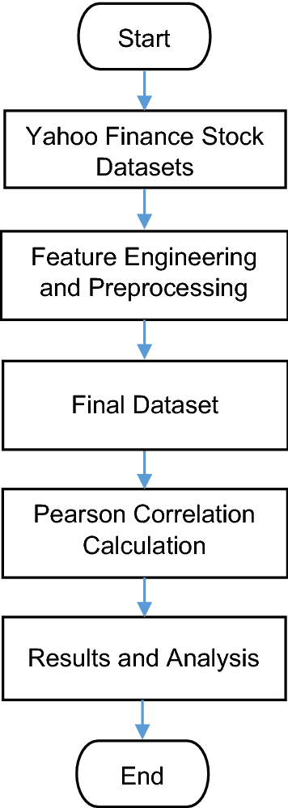

# CHAPTER 8

**Test Cases**

# Software Testing:

If we have any desire to guarantee that our product is bug or stable, we should play out the different sorts of programming testing since testing is the main strategy that makes our application without bug. The order of programming testing is a piece of different testing exercises, like test methodology, test expectations, a characterized test objective, and so forth. Also, programming testing is the execution of the product to track down defects.

There are two type of software testing that is:

# Manual Testing:

Testing any product or an application as per the client's requirements without utilizing any computerization instrument is known as manual testing. We require no exact information on any testing apparatus to execute the manual experiments. We can easily set up the test report while performing manual testing on any application.

There are mainly three types of manual test that is

### White Box Testing:

In white-box testing, the designer will review each line of code prior to giving it over to the testing group or the concerned test engineers

Thusly, the code is perceptible for designers all through testing; that is the reason this interaction is known as WBT (White Box Testing).

### Black Box Testing:

Black box testing is a course of really looking at the usefulness of an application according to the client necessity. The source code isn't apparent in this testing; that is the reason it is known as black-box testing.

### Grey Box Testing:

It is a joint effort of black box and white box testing. We can say that in the event that a solitary individual group done both white box and black-box testing, it is viewed as grey box testing.

# Automation Testing:

The main piece of Programming testing is Computerization trying. It utilizes explicit devices to robotize manual plan experiments with next to no human obstruction. Computerization testing is the most effective way to improve the proficiency, efficiency, and inclusion of Programming testing. It is utilized to re-run the test situations, which were executed physically, rapidly, and over and over. Whenever we are trying an application by utilizing a few devices is known as mechanization testing.

# Test Cases:

|  |  |  |  |  |  |  |
| --- | --- | --- | --- | --- | --- | --- |
| **Test Case**  **ID** | **Test Case** | **Input Test Data** | **Steps to be Executed** | **Expected Result** | **Actual Result** | **Pass/Fail** |
| 1 | User must login Successfully. | Correct Username, password | 1.Enter Username 2.Enter  password | Login Successful | Login Successful | pass |
| 2 | unregistered users is not able to login to the site | incorrect username, incorrect, password | 1)Enter input(incorrect) username and password on the respective fields 2)click  submit/login | Error must be displayed | Error Display on Screen | Pass |
| 3 | Test with empty username and valid password such that login must get failed | empty username and valid password | 1)leave the username empty in the user id and enter a valid user‘s password in the password  field | Proper error  must be  displayed and prompt to enter login again | Error Display on Screen | Pass |
| 4 | Automatic logout of the site when pressing backspace button | Registered username and password | 1) Login to the site using registered username and password 2)now  press backspace | User must logout of the site properly | User Log Out properly | Pass |

**CHAPTER 9 WORKING MODUL**

# Module:

In this project there are basically two main modules first is user module and second is admin module. User module contains the different type of services like entrepreneur, professionals and business. Admin module has control over the overall project platform. We are creating user profile so user can control all activity using the profile.

# Code:

**Main Page :**

import streamlit as st

import smtplib

import pandas as pd

import pdf2image

import tempfile

import subprocess

from subprocess import Popen

import random

import pandas as pd

# Set the background color using CSS

st.markdown(

"""

<style>

body {

background-color: #f0f0f0;

}

</style>

""", unsafe_allow_html=True

)

# Function to add a background image using CSS

def set_background_image(image_url):

background_style = f"""

<style>

body {{

background-image: url('{image_url}');

background-size: cover;

}}

</style>

"""

st.markdown(background_style, unsafe_allow_html=True)

# Set the background image for the "Login" section

set_background_image("images/undraw_file_sync_ot38.svg")

# Define the CSV file name to store user data

CSV_FILE = "user_data.csv"

# Function to initialize the CSV file with a header if it doesn't exist

def initialize_csv():

try:

df = pd.read_csv(CSV_FILE)

except FileNotFoundError:

df = pd.DataFrame(columns=["Username", "Password"])

df.to_csv(CSV_FILE, index=False)

# Function to check if a user is an admin

def is_admin(username, password):

return username == "aniruddha" and password == "Aniruddha@1204"

# Function to check if a user exists in the CSV

def user_exists(username, password):

df = pd.read_csv(CSV_FILE)

return any((df["Username"] == username) & (df["Password"] == password))

# Function to send feedback to your email

def send_feedback_to_email(feedback_message):

# Replace with your App Password and Gmail account

app_password = "your_generated_app_password"

sender_email = "your_email@gmail.com"

receiver_email = "aniruddhakasar2001@gmail.com"

try:

# Connect to the SMTP server

server = smtplib.SMTP("smtp.gmail.com", 587)

server.starttls()

server.login(sender_email, app_password)

# Send the email

server.sendmail(sender_email, receiver_email, feedback_message)

server.quit()

except Exception as e:

st.error(f"Failed to send feedback email: {str(e)}")

# Sidebar for navigation

choice = st.sidebar.radio("Navigation", ["Home", "Login", "Register"])

# Home page

if choice == "Home":

# Define a dictionary for service information

services = {

"Service 1": "Description of Service 1",

"Service 2": "Description of Service 2",

"Service 3": "Description of Service 3",

}

# Define information about yourself

about_me = """

I am Aniruddha Kasar, a Junior Data Scientist with experience in working on various projects. I am passionate about data science and continuously working on innovative solutions.

This entire project is developed by me, and it serves as a showcase of my skills and achievements.

You can explore research papers and projects by selecting the tabs from the dropdown menu.

"""

# Display a dropdown menu for selecting the section

section = st.selectbox("MENU", ["Select a Section", "Services", "About Us", "Support"])

# Display the selected section content

if section == "Services":

st.header("Services")

for service, description in services.items():

st.subheader(service)

st.write(description)

elif section == "About Us":

st.header("About Us")

st.write(about_me)

# Display a window for research papers

st.header("Research Papers")

st.write("Explore research papers in this window.")

research_papers = [

{"title": "IJSREM Manuscript Template",

"file_path": "F:\stock price prediction\documents\IJSREM-Manuscript-Template.pdf"},

# Add more research papers if needed

]

for paper in research_papers:

if st.button(f"View {paper['title']}"):

with open(paper['file_path'], 'rb') as pdf_file:

pdf_file_bytes = pdf_file.read()

with tempfile.NamedTemporaryFile(delete=False, suffix=".pdf") as tmp_file:

tmp_file.write(pdf_file_bytes)

st.image(pdf2image.convert_from_path(tmp_file.name))

# Display certificates

st.header("Certificates")

certificates = [

{"title": "Certificate 1", "file_path": "certificates/certificate1.pdf"},

{"title": "Certificate 2", "file_path": "certificates/certificate2.pdf"},

for certificate in certificates:

st.markdown(f"[{certificate['title']}]({certificate['file_path']})")

elif section == "Support":

st.header("Support")

st.write("If you need any assistance, please contact us.")

# Add your email and mobile number

st.write("Email: aniruddhakasar2001@gmail.com")

st.write("Mobile: (+91) 9359205639")

# Feedback form

st.subheader("Feedback Form")

form = st.form(key='feedback-form')

email = form.text_input("Your Email (Mandatory)")

query = form.text_input("Query (Mandatory)")

description = form.text_area("Description (Optional)")

if form.form_submit_button("Submit Feedback"):

if not email or not query:

st.error("Both Email and Query are mandatory fields. Please fill them.")

else:

# Process the feedback and send it to your email

feedback_message = f"Email: {email}\nQuery: {query}\nDescription: {description}"

# Send feedback to your email address

send_feedback_to_email(feedback_message)

st.success("Thank you for your feedback! We will get back to you soon.")

# Login page

elif choice == "Login":

st.markdown(

"""

<style>

.contents {

text-align: center;

}

img {

max-width: 100%;

}

</style>

""",

unsafe_allow_html=True,

)

st.markdown("<h1 style='text-align: center;'>Sign In to <strong>GlobalStock</strong></h1>", unsafe_allow_html=True)

st.write("")

username = st.text_input("Username")

password = st.text_input("Password", type="password")

if st.checkbox("Remember me"):

st.write("Remember me is checked.")

if st.button("Log In"):

if is_admin(username, password):

st.success("Logged in as admin.")

try:

result = subprocess.run(["streamlit", "run", "global.py"], capture_output=True, text=True, check=True)

st.code(result.stdout, language="python")

except subprocess.CalledProcessError as e:

st.error(f"Error running the script: {e}")

# Replace with your logic for running 'global.py' if needed.

elif user_exists(username, password):

st.success(f"Logged in as:{username}")

try:

result = subprocess.run(["streamlit", "run", "global.py"], capture_output=True, text=True, check=True)

st.code(result.stdout, language="python")

except subprocess.CalledProcessError as e:

st.error(f"Error running the script: {e}")

elif choice == "Register":

st.markdown("<h1 style='text-align: center;'>Register In to <strong>GlobalStock</strong></h1>", unsafe_allow_html=True)

st.write("")

user_data_df = pd.read_csv("user_data.csv")

new_username = st.text_input("New Username")

new_password = st.text_input("New Password", type="password")

if st.button("Register"):

if new_username in user_data_df["Username"].values:

st.warning("Username already exists. Please choose another.")

else:

is_admin = False

if new_username == "admin": # You can customize the admin username

is_admin = True

new_user_data = pd.DataFrame({"Username": [new_username], "Password": [new_password], "IsAdmin": [is_admin]})

user_data_df = pd.concat([user_data_df, new_user_data], ignore_index=True)

user_data_df.to_csv("user_data.csv", index=False)

st.success("Registration successful. You can now log in.")

# Snapshots:

### Home Page:

Above page about the home page of the platform for mobile site whenever user visits to the site f above page first shown to user. Home page also contain the menu bar so all other services are listed in menu bar which offer by platform.

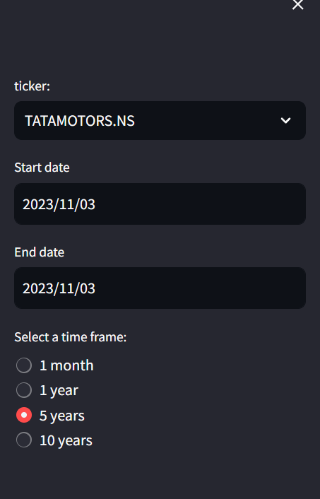

### Home Page For Desktop Site:

Above page is home page for the desktop site it has all the services are listed at above the page.Also the search bar are there to search any services which offers by the platform.

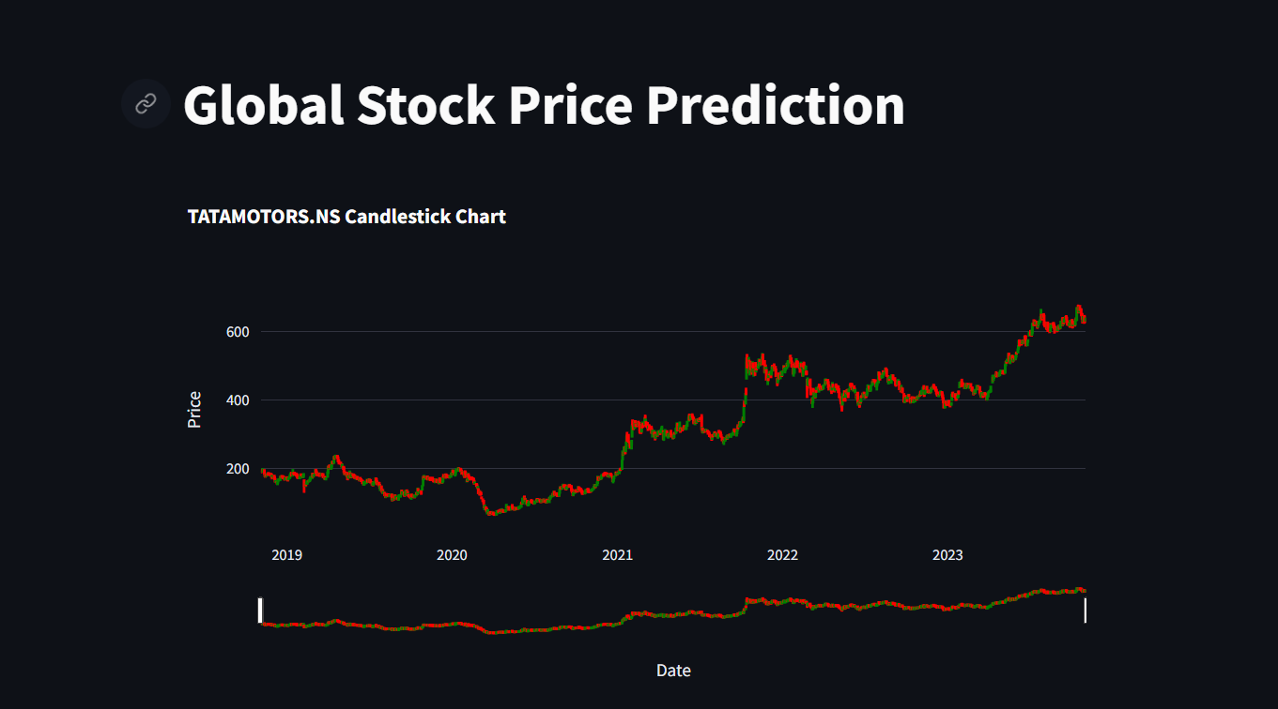

**CHAPTER 10**

**PROJECT PLAN**

**10.1 Fig: Project Plan**

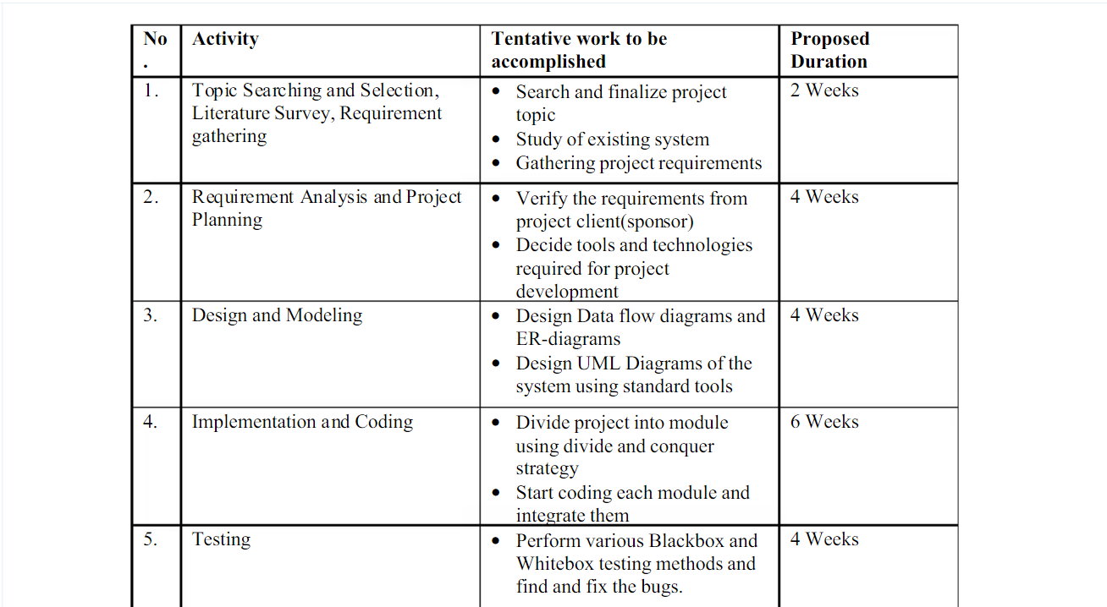 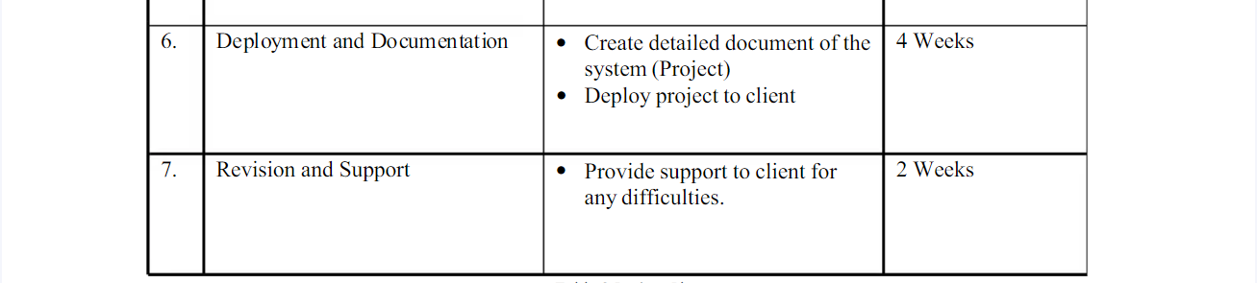

# CHAPTER 11 CONCLUSION

We conducted numerous experiments to determine whether our model trained on certain patterns in stock charts from a single country can make a profit not only in the given country but generally in all other countries. As our results show, our model trained in only the US market, also performed well or even better in many other markets for the 12-year testing period. Based on this observation, artificial intelligence and machine learning stock price forecasting studies, which have been conducted in only a single country so far,

can be employed in global stock markets. In other words, if the model structure, input feature, and training procedure are satisfactory, the model does not have to be trained and tested in the same market. To the best of our knowledge, our artificial intelligence based model, which is trained on the data of only a single country, is the first to obtain numeroustesting results on global stock markets.

# BIBLIOGRAPHY

1. Investopedia. (n.d.). Efficient Market Hypothesis: Is The Stock Market Efficient? Retrieved June 24, 2015, from Investopedia: http://www.investopedia.com/articles/basics/04/022004.asp
2. Bollen, J., Mao, H., & Zeng, X. J. (2010). Twitter mood predicts the stock market. arXiv. [3] Stock Price Prediction Through the Sentimental Analysis of News Articles Jaeyoon Kim, Jangwon Seo:Minhyeok Lee: Junhee Seok 2019 Eleventh International Conference on Ubiquitous and Future Networks (ICUFN) Year: 2019 Conference Paper Publisher: IEEE.
3. Applying long short term momory neural networks for predicting stock closing price Tingwei Gao; Yueting Chai; Yi Liu 2017 8th IEEE International Conference on Software Engineering and Service Science (ICSESS) Year: 2017 | Conference Paper Publisher: IEEE
4. Impact of financial ratios and technical analysis on stock price prediction using random forests K. S. Loke, 2017 International Conference on Computer and Drone Applications (IConDA). Year: 2017 Conference Paper | Publisher: IEEE
5. Stock price prediction using genetic algorithms and evolution strategies Sonal Sable; Ankita Porwal Upendra Singh 2017 International conference of Electronics, Communication and Aerospace Technology (ICECA) Year: 2017 | Volume: 2 | Conference Paper | Publisher: IEEE

# Appendices:

## **A**. Published Papers and Certificate:

## 

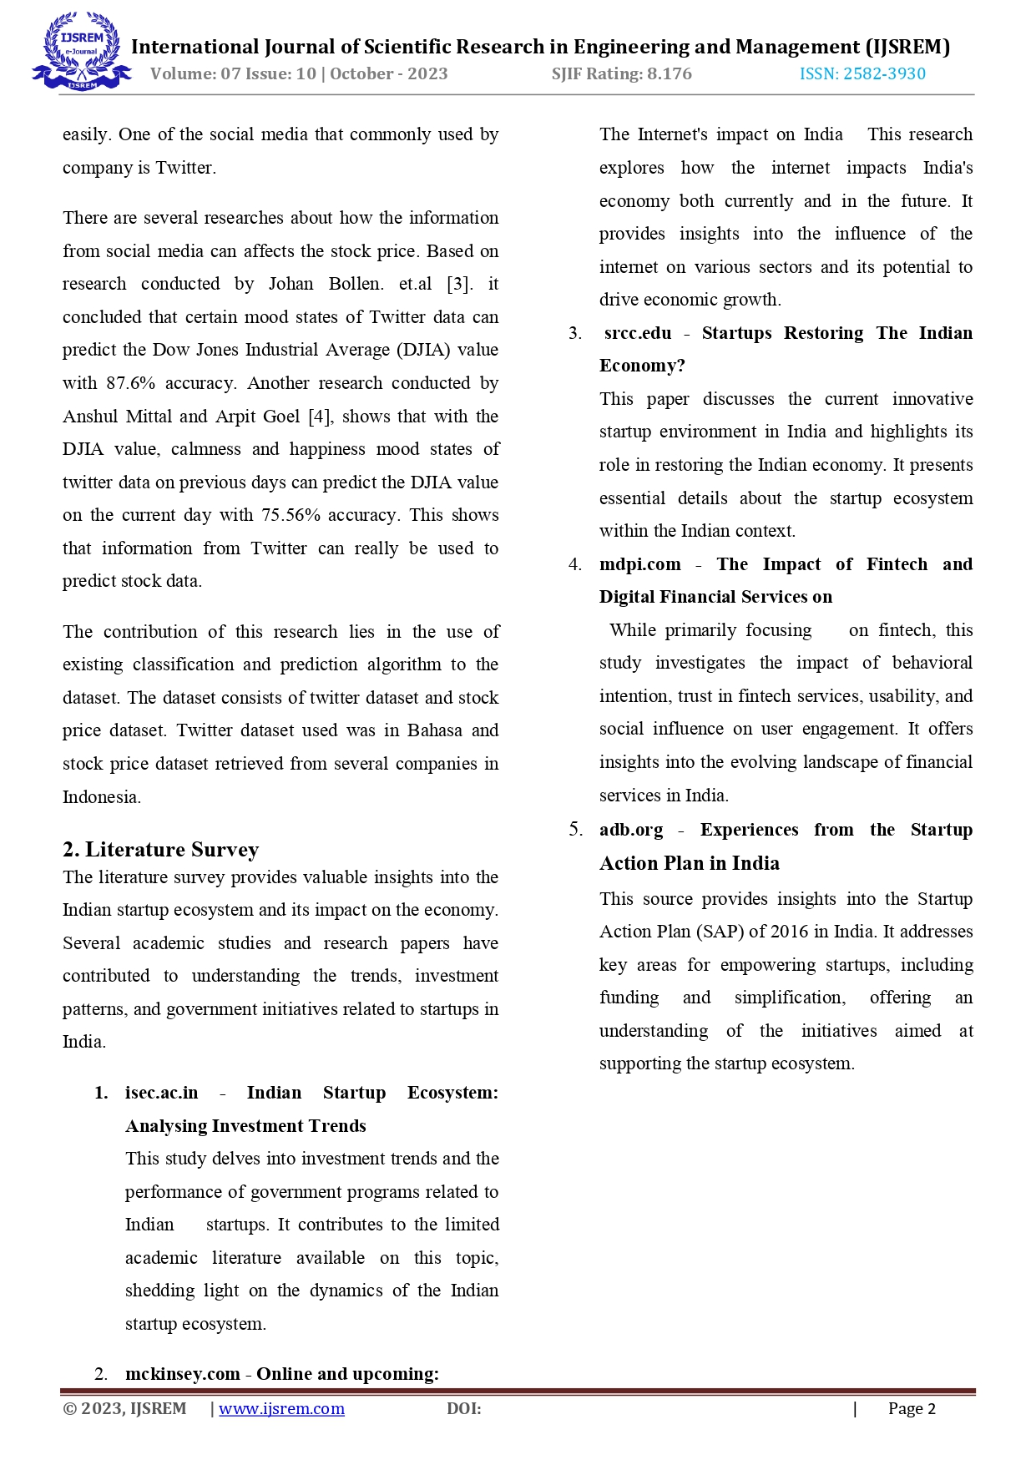

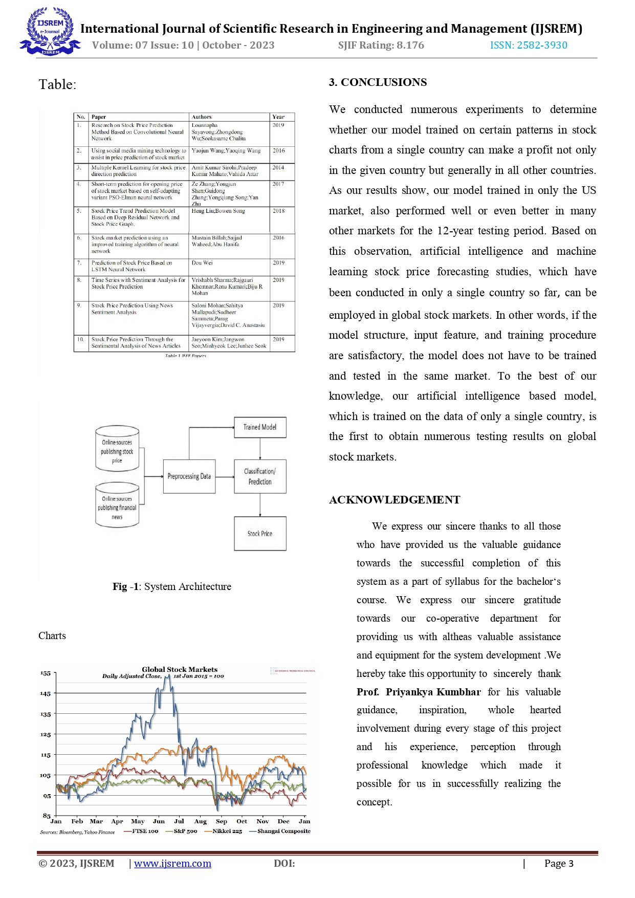



**Certificate :**

